COVER PAGE

Contents

Game Description: 2

Gameplay: 2

Story: 2

Goal: 2

Map: 2

Player Skill: 2

Mechanics: 3

Enemies (bots): 3

Buttons: 3

Death: 4

Platforms: 4

Levels: 4

0: 4

1: 4

2: 4

3: 4

4: 6

5. 6

6. 7

7: 9

8: 9

9. 10

10. 10

Graphics and styling: 11

Music and Sound effects: 11

Details: 11

# Game Description:

The game is a single player first-person puzzle solving survival game. The player has to progress through various levels to complete the game. Each level gets progressively challenging with a large variety of mind-boggling modules. You spawn as a simple red capsule with no character and no equipment. You complete a few puzzles to find a special pistol. This pistol has the ability to shoot and push objects in close proximity. These are the two essential mechanics of the game, on which majority of the game revolves around.

# Gameplay:

## Story:

It is the year 2051, you have been captured by a terrorist organization whose main objective is to brainwash and recruit young adults. Many attempts have been made to escape the facility in the past but none could make it out. The only way out is to go through all the remaining rooms one by one, each of which have a challenging puzzle to crack. Take too long and you die of starvation and dehydration. You have made it to this point with only about 10-12 rooms left to make your way out. Do you have it in you to be the first survivor of this facility?

*Note: It must be noted that all the images used in this document are intended for the orientation or structure of the described object(s) and does not represent the final textures that will be used in the game.*

## Goal:

The main objective of the game is to progress through all levels, one by one and reach the end and escape the facility to reclaim your freedom.

## Map:

The player can go only in a set path, level by level which consists of various terrains built using the unity terrain builder.

## Player Skill:

The player can pick up **one weapons** in the game, which they can find after completing the first two levels. It is a simple **pistol** which has two functions, **shooting and pushing** other objects. The player can shoot objects and **enemies** to destroy them. The enemies explode if they are within a few units from the player or if the player pushes them. The player can use this mechanic to progress through the levels. There are **dynamites,** shooting which causes them to explode, adding an explosion force on nearby objects. There are two types of **buttons**: horizontal and on the ground(vertical). The player can push the horizontal buttons placed in walls with the pistol. However, the player does not have a rigidbody or mass and hence cannot stand on the buttons on the ground to activate them. Any rigidbody has a sufficient mass to activate the button on the ground. Finally, there is sea saw type objects in the game which helps the player to get to a higher place. The player can die in two possible ways, one by falling off the map and the other by the exploding bots.

## Mechanics:

The player has a character controller with a simple movement script. The player can **move in all directions with wsad, jump with the spacebar and crouch with c**. When the pistol is equipped, pressing **right click will push an object** in the direction the gun is facing. The gun has a range of 7 units beyond which it cannot push objects. The **left click on the mouse shoots the gun**. If the crosshair is on any object, it will take damage, **each shot does 40 damage**. Objects have different amounts of total health. The wooden crates have 80 health and the bottles have 30. The shooting is done using raycast and there is no bullet travel time. Objects interact with other objects in the game with all regular physics components.

## Enemies (bots):

**Exploding bots** exist in higher levels of the game. These bots have a health of 50 and have a **navmesh** on them using which they will come towards the player when the player is within a fixed radius around them**. When the bots reach a distance of 5 units from the player, they stop moving and an explosion is triggered**. After 3 seconds of explosion animation, an explosion force is added to the player and all rigid bodies in the explosion radius. The player takes a certain amount of damage depending on their distance from the bot. The 3 seconds of animation gives the player time to move away from the explosion radius. **If the player takes enough damage, he dies and respawns at the starting of the level**

## Buttons:

The buttons are made in unity itself.

The buttons on the ground function in the following way:

A rigidbody cylinder is placed inside on a cube whose height is smaller than that of the cylinder. **Lock the x, z, x rot, y rot, z** rot of this rigid body. Leaving some space below the end of the cylinder, place a cube. Make the cube **IsKinematic** and attach a script such that when it collides with a rigidbody, the IsKinematic becomes false. And the cylinder goes down. When it collides with the second cube, the function the button is supposed to do is activated.

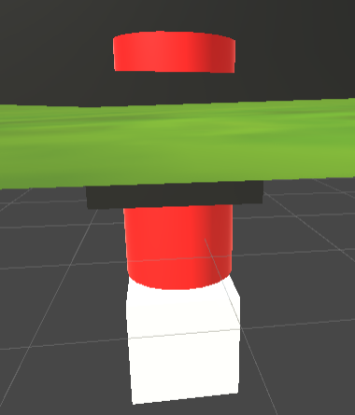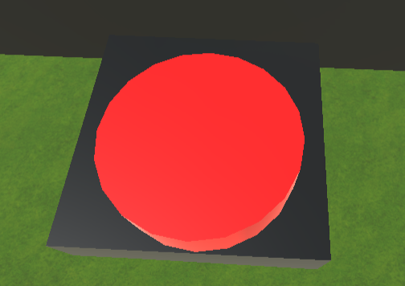

## Death:

If a player falls off the map or dies due to the explosion of the bot, he respawns at the start of the level. Additionally, the player can press r to start from the beginning.

## Platforms:

1. Crates/wooden planks/walls: These surfaces can only be walked on i.e., the player cannot jump when on these planks.

2. Stone planks/terrain: When on these layers, the player can jump and crouch.

## Levels:

Before the levels start, there is a small cutscene describing the story.

### 0:

After the animation, the player is spawned in a small room where all the basic mechanics of movement is explained via text. This room is slightly below the ground and has a small bench and a bed aligned in a way that the player can jump on one another and get out of the room.

### 1:

In this level a pistol is fallen on the ground. There are a few crates and bottles and other random objects lying on the ground for the player to test the newly found gun on. The room ends with a small door with two crates stacked on top of each other slightly blocking the entrance to the next level. The player has to push or destroy the crates to go on to the next level.

### 2:

In this level, there is a horizontal and a vertical button next to each other, each of which reveals a plank using which the player can jump on to the next level. This horizontal button is located on a wall behind a glass pane. The glass pane has a health of 40, shooting it twice will destroy it. The vertical button has a crate near it so that the player can push it onto the button. Activating both these buttons are required to move on to the next level.

### 3:

On entering this level, there is a wall with planks placed in such a way that the player is able to navigate to the top of the wall by jumping on these planks. The picture below will give a better understanding of the layout of the planks.

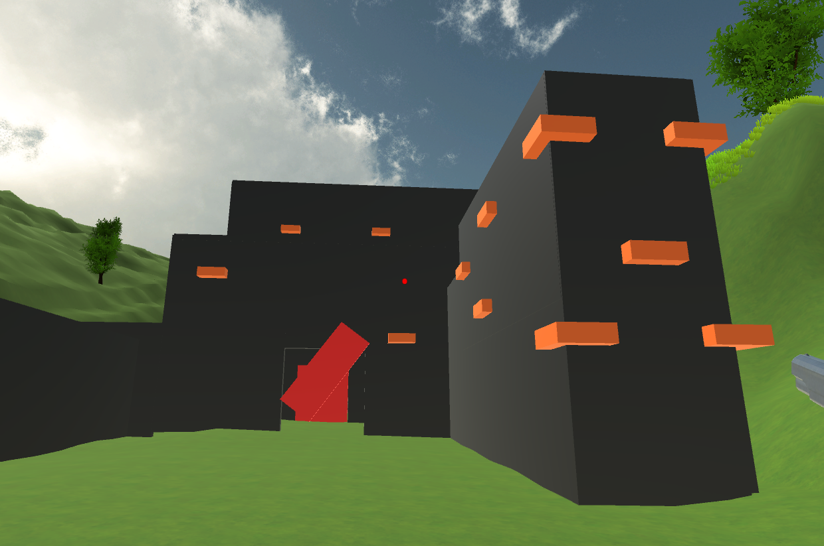

On the other side of the wall is a compartment with a sea-saw inclined towards the player. This sea-saw has a box on the other end which is at the higher level. The sea-saw is attached to a wall which has a shelf with bottles on top of it. These bottles have a box collider and a rigid body with a mass of 1. When the bottle falls in the box the sea-saw is lifted up due to the bottle’s weight.

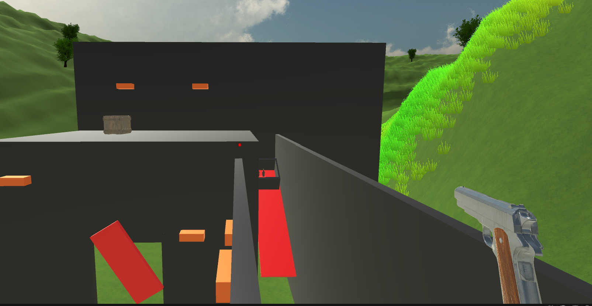

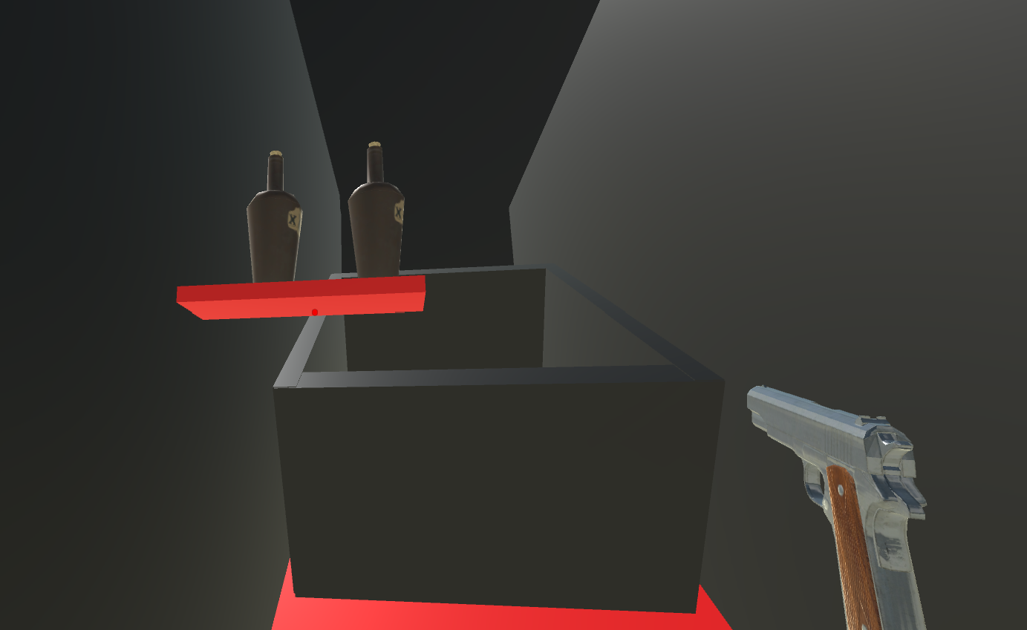

A crate is present in the top of the room which is required to enter the room. The entrance to this room has a spinning plank which prevents the player from going inside. The plank is a rigidbody and its position and rotation (except y) is fixed. Behind the plank at the entrance of the room is an invisible wall preventing the player to glitch through the rotating plank. The box on top of the room is pushed down and is supposed to be used to stop the spinning plank so that the player can go through it. When the box collides with the spinning plank, the invisible wall is destroyed.

On entering the room there are two shelves, one on the right and one on the left, both of which have a button under them and a crate on them. The left crate is smaller in size so that the player cannot see it form the ground. The buttons are positioned in such a way that the crate can fall on it when pushed form below. The button on the right activates 2 stone planks which will help the player to reach the crate on the left to push it on the button. The button on the left opens the door for the next level.

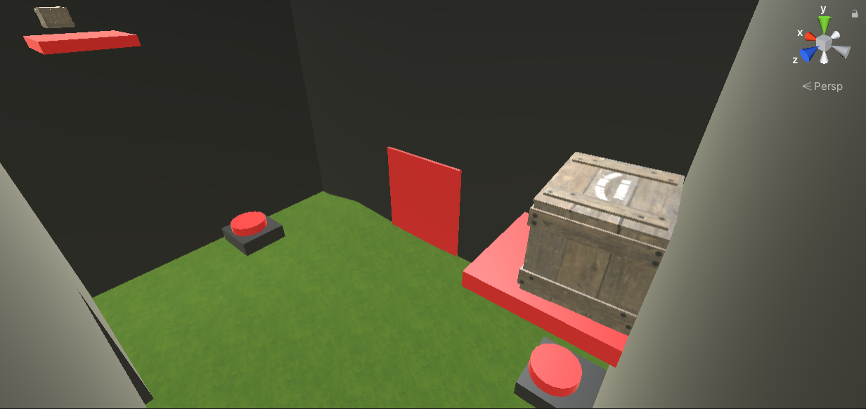

### 4:

This room is a much bigger room than the previous one. The crates are arranged as seen in the picture below. There is a horizontal button behind the hole seen in the right wall. The player is supposed to reach there by interacting with the crates above, destroy the crate in the hole and push the button to open the door. Opening of the door has a simple rotating animation. The pile of wood and other decorative objects on the left is to ensure walking from plank to plank is smooth.

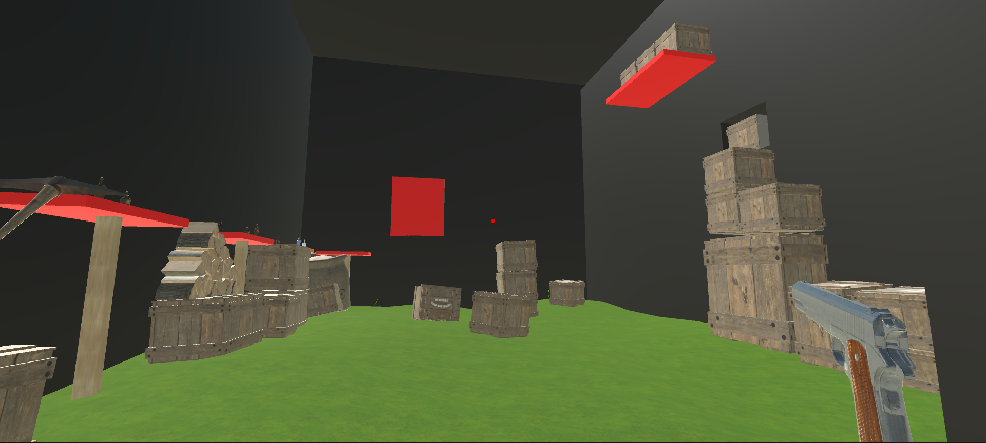

### 5.

This level introduces the player to dynamites. The dynamite has the ability to blow up doors and hatches when in its explosion radius. It also adds an explosion force on any rigidbody in its radius. This is a small narrow room with 3 buttons and a box which houses a dynamite. The dynamite in the box respawns every 5 seconds.

Two of the three buttons are hidden behind a wall. The first button is placed on the ground. There is a shelf with boxes stacked upon each other such that shooting one box will cause the other boxes to fall down

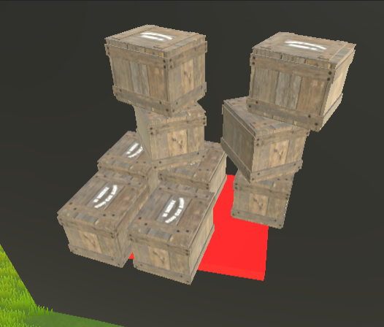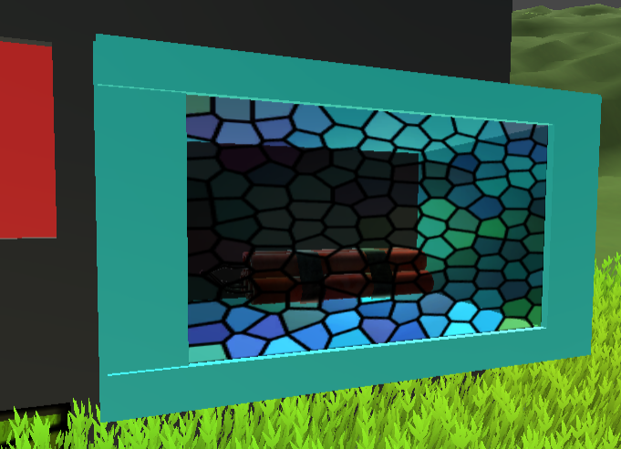

Place a button right below the approximate area in which the boxes can fall. These boxes are at a height beyond the pushing range of the gun. This button activates a small door which reveals 4 boxes in a groove in the wall. On the other side of the wall is a button under one of the boxes. The lower part of the wall is made of glass texture. This makes the other side of the wall slightly visible. The button is placed behind the end part of the glass such that it is hidden in the grass and is not easily visible. Activating this button will activate a piston behind the dynamite, pushing it from the box. On the opposite wall is a small hole placed such that the dynamite goes through it. This should be used to push the dynamite to the next level. A dynamite is also needed for the current level. To prevent the dynamite from going through the hole, the player can push it or just stand in front of it and use it to blow up the boxes leading to the next level. Since the dynamites keep respawning, the player can use it for both the levels.

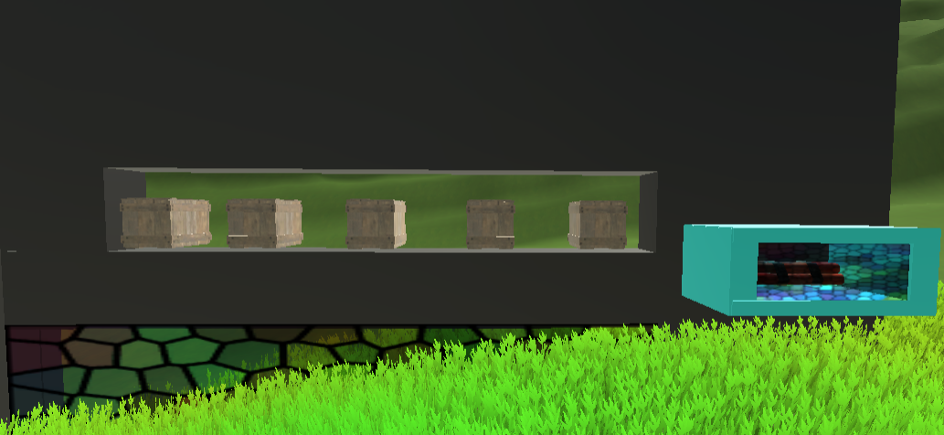

### 6.

For this level make a hole in the terrain and make a hatch exactly the size of the hole. The hatch opens upon the explosion of a dynamite hidden in the grass. There are a few boxes randomly placed on the hatch so that it is not easily visible (layout as seen in the figure below). Below the hatch, make several rooms each of which serves a purpose.

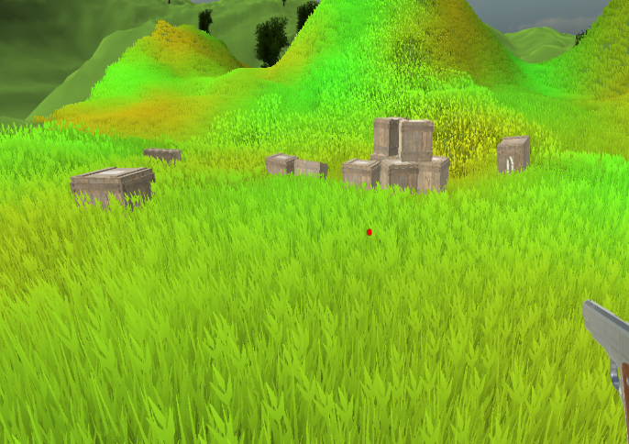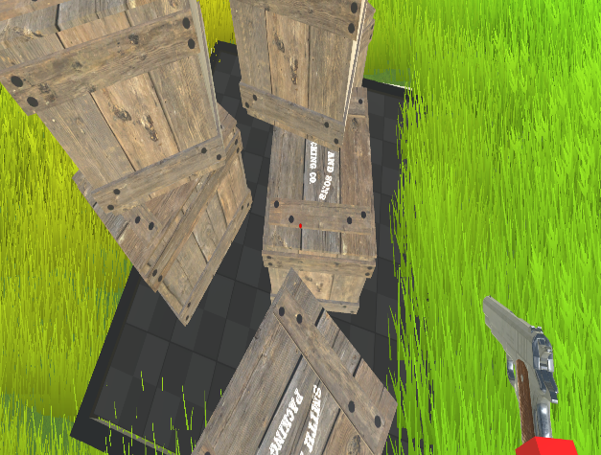

The main room has four crates with bottles on top. One crate is on the left side and the other three are on the right. The crates on the right have small cylinder with color codes embedded in them. The left wall has one open hole and several randomly placed small windows so that the player can subtly see the contents of the room adjacent to the main room. The opposite wall of this room is exactly 7.5 units from the first wall such that a horizontal button cannot be pushed by the player. This horizontal button is placed exactly opposite to the open hole such that the player can see it but cannot push it. Behind one of the windows, a vertical button is placed with a crate next to the open hole. The crate is placed in such a way that the player can barely see the end of the crate from the hole. Activating this button creates a large platform spanning from the button on the wall to the open hole. A crate then falls on this platform and the player is supposed to push the crate to the inaccessible button to activate it. There is another room in front and right of the main room, activating this button opens the door of that room. In 3 bottles are placed on top of 4 planks of different colors. As mentioned before, the main room has crates with a color code on them. The player must match the color code of the planks in the room to that on the crates. If the number of bottles on the crate of the right color is equal to the number of bottles in the room, the door to the next level opens.

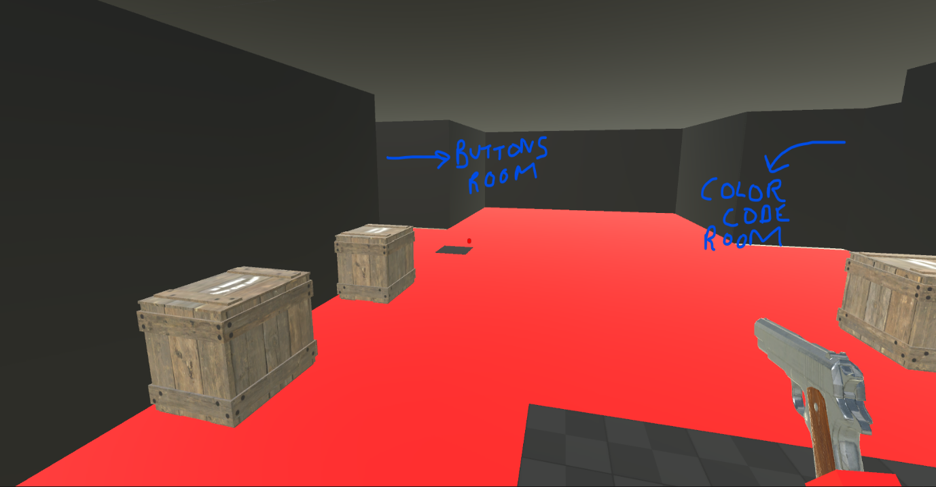

*The image only shows the arrangement of the rooms as described by the above paragraph.*

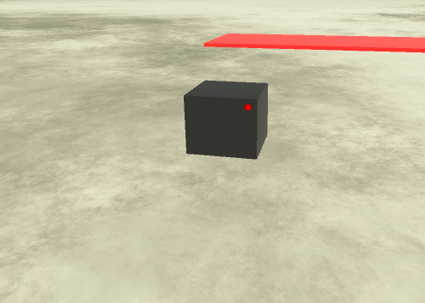***[STORY LINE]:*** In between this and the next level, there is a small floating plank. The player has to jump on this plank in order to go to the next level. When on this block, a text or an audio message plays asking the player if he/she thinks whatever they are doing is is worth it. It gives the player an option to jump off the platform to end the misery. It tells the player that the levels are only going to get challenging and reminds the player that nobody has made it to the end in over 20 years.

### 7:

This level introduces the player to exploding bots. A button activates the navmesh of a bot in the room. The player can guide it to a door and trigger its explosion to go to the next room.

After this, there is a bot behind a glass pane. This glass pane has a crate in a hole in it. It is positioned in such a way that the player is supposed to use the explosion of the bot to get the crate towards the player. This crate should then be pushed to a button that opens a ramp that takes the player back to the ground level.

Additionally, the walls have a few drawings to help the player understand the mechanics of the bot and how they can be used in the next level.

### 8:

This level is located in a forest. Bots are randomly placed thought the area. The bots can kill the player in case they get too close to the explosion radius. There is a ditch in the beginning of the jungle with many crates in it. As seen in the image the ditch deep enough so that the player cannot just push the crates out of it with the gun. There are two buttons in the middle of the forest and the player is supposed to use the explosion force of the bots to launch the crates out of the ditch and push it onto the buttons. Activating both the buttons opens the door to the next level. This door opens in such a way that it acts as a ramp for a wooden bridge on top of which the next level is located.

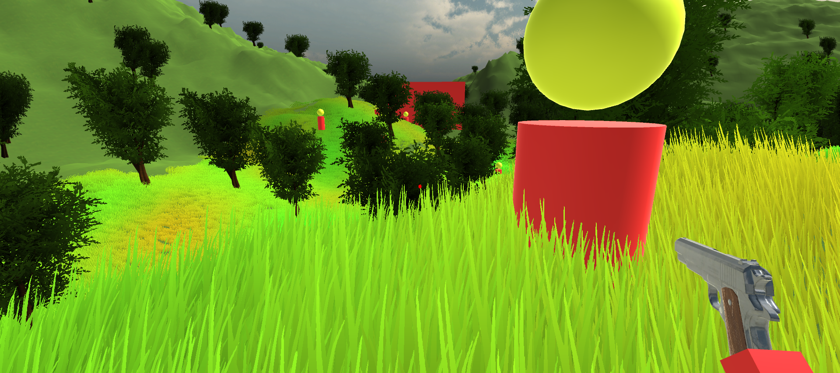

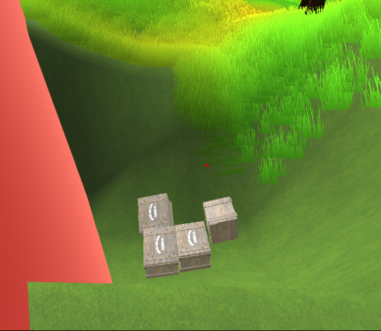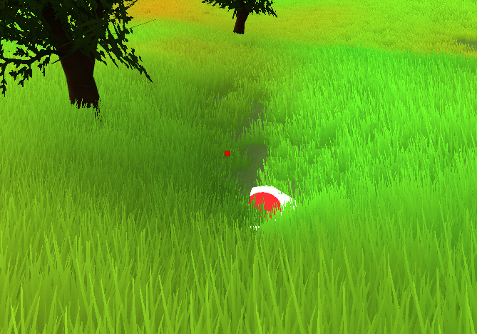

*The button in the middle is also in a small ditch to make it easier for the player to push the crate on the button.*

### 9.

This level is on a broken-down wooden bridge in a valley. The valley is made by raising the terrain around it. Several bots can enter the level from the elevated areas on either side of the valley. There are boxes that are randomly placed around the bridge which can be used to stop the bots from entering the bridge. Half way through, the bridge is broken down and the next part of it is slightly elevated so that the player cannot jump on top of it. There are crates around the player and the player has to use the explosion force of the bots to get a crate to the bridge so that he can climb on top of it to go to the next part of the bridge. After shooting out a few bots the player gets to the end of the bridge where he can jump down to the next level. There is a horizontal button, which activates a wall behind the player to prevent further entry of bots from the previous level.

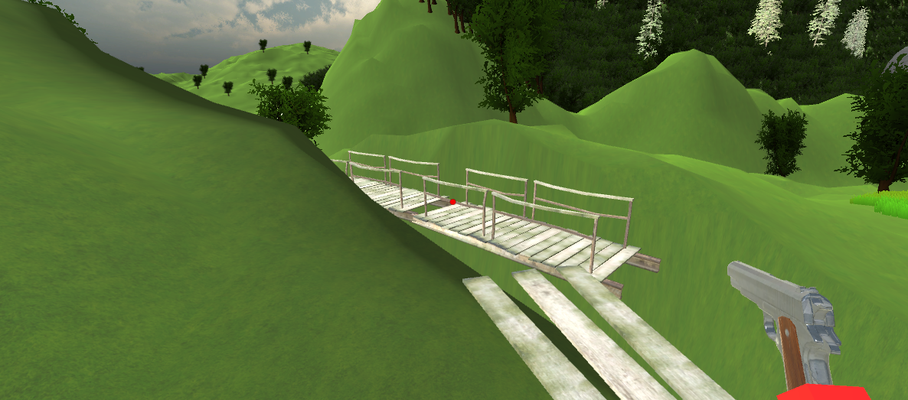

### 10.

This is the last level of the game and the player escapes the facility on completion. There is a huge gap (hole in the terrain) with nothing in it. There are huge mountains on either side of the empty space. As soon as the player enters the level, a very large swarms of bots start coming from the mountains towards the player. The bots spawn infinitely till the player reaches the end. There is a wall with a few buttons on them which serves as the last puzzle. It is a combination of all previously used puzzles. The enemies charging towards the player act like a timer before which the player has to solve the puzzle. There are too many bots for the player to shoot and eliminate. On solving the puzzles, platforms are revealed in the empty area. The player has to jump on them to evade the oncoming bots and finally make it to the end. If the player respawns at the start of the level in case he falls into the void while attempting to jump across.

# Graphics and styling:

The backdrop is a mountainous remote region and the art styling is of that of a creepy testing facility or a dungeon. The walls have an eerie feeling to them giving the player a sense of loneliness. A few of the walls have text written with blood of past survivors. Some of these are hints to complete the level. Even though it is a bright day, the setting gives off a creepy vibe to the whole place. The bot is a yellow sphere on top of a red cylinder depicting its simple characterless nature. Aesthetics were not kept in mind while designing the bot as its sole function is to be a ruthless killing machine. The doors are mostly taken from the dungeons pack from the unity asset store. The planks which the players can jump on are made of a stone material. Wooden planks are fragile and players cannot jump while on them. The shape and material for the dynamite is taken from brackey’s western pack assets. The recoil animation and gun floating animation is made in unity itself with the animator. Terrains, grass and trees were taken from the unity asset store.

The floor of the underground level is made of a metal grill.

Apart from this the world is decorated with assets from the unity particle system. This includes the tap with water drops dripping from it, the explosion from the dynamite and the muzzle flash from the pistol. Blood stains can be used from this asset as well.

The skybox is also taken from the unity asset store.

Different levels of lighting and effects can be used depending on the location.

Through the game, a lot of foreshadowing is done with the help of animations and subtle hints.

# Music and Sound effects:

Most of the game has an eerie music as a background. The objects that have sound effects on them include the pistol, crates upon falling, dynamites and bots exploding and buttons activating. Doors opening have creaking sounds. In addition to this, a voice line to the main story can be added if feasible. Random war noises are heard once in a while.

# Details:

**Crew involved in making the game**: S V Sumanth

**Name of the game**:

**Genre**: Puzzle/First Person

STORY:

It is the year 2051

You have been captured by a high profile terrorist organization which is causing havoc around the world. You are one of many innocent civilians kidnapped and are being brainwashed to work for the organization.

Luckily, you are a stubborn bitch and several attempts at brainwashing you have resulted in a failure. Being alive and sane for so long you have had enough time to plan out an exit strategy. You stole the keys to the first room and a pistol from a guard a few weeks back. This may help you escape.

You are kept in a remote facility in the middle of the alps. The government has made several attempts to save any remaining survivors which lead to violent conflicts. In the most recent one, the debris resulting from the clash has broken your cage and you can make an attempt to escape through your previously planned strategy.